**Assignment**

**Restful Web Services, Part-1**

Date-5/03/21

**NOTE**-For URI-> /Employee, please consider /employee in the code, necessary changes has been made in the project.

Q1)Create a simple RESTful service in Spring Boot which returns the Response "Welcome to spring boot".

Answer

GreetingsController.java

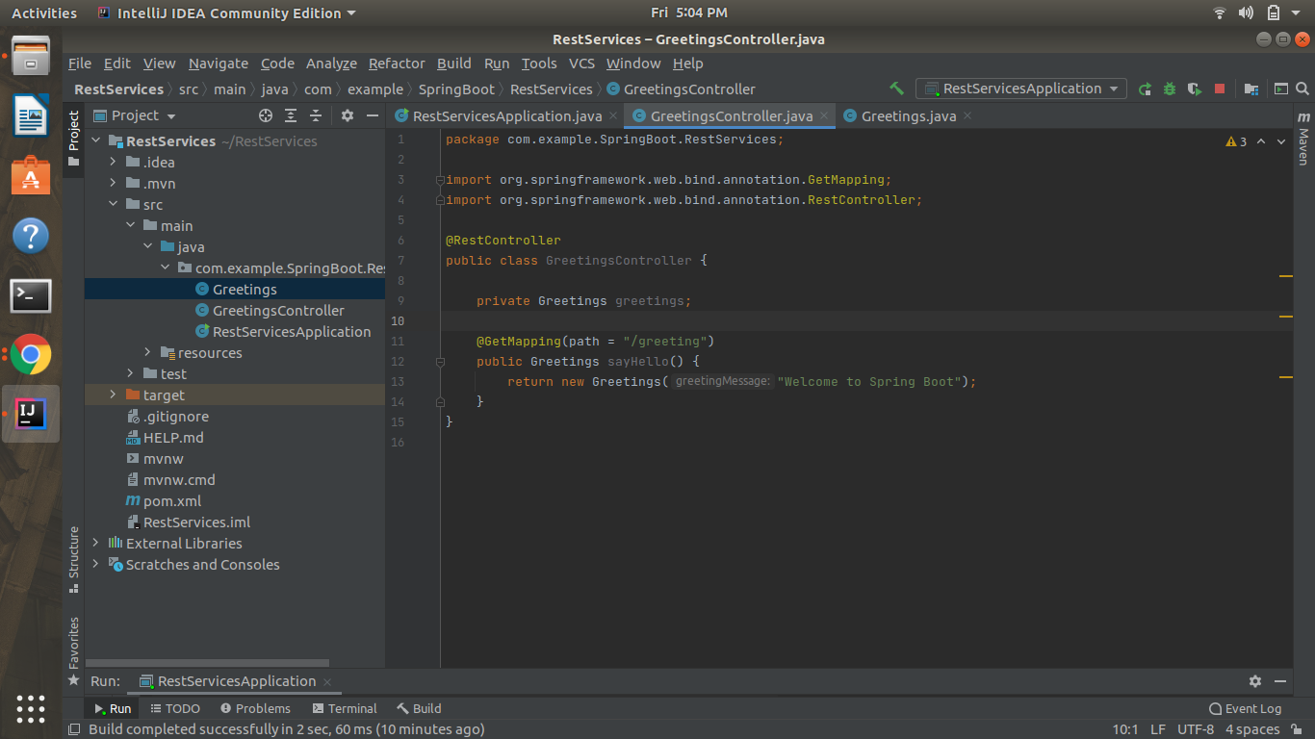

Greetings.java

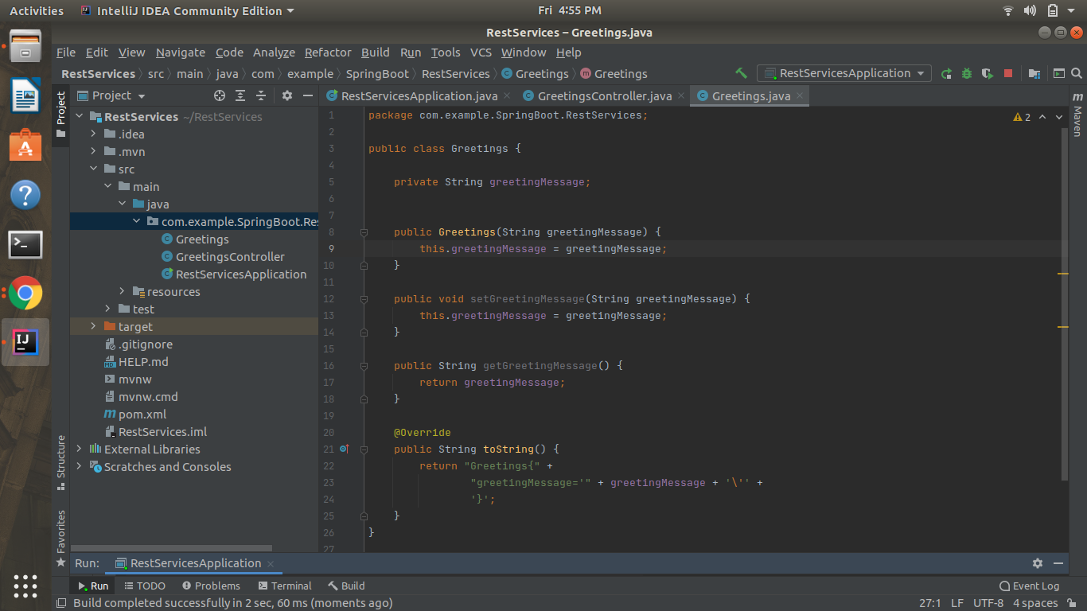

Output(localhost:8080/greeting)

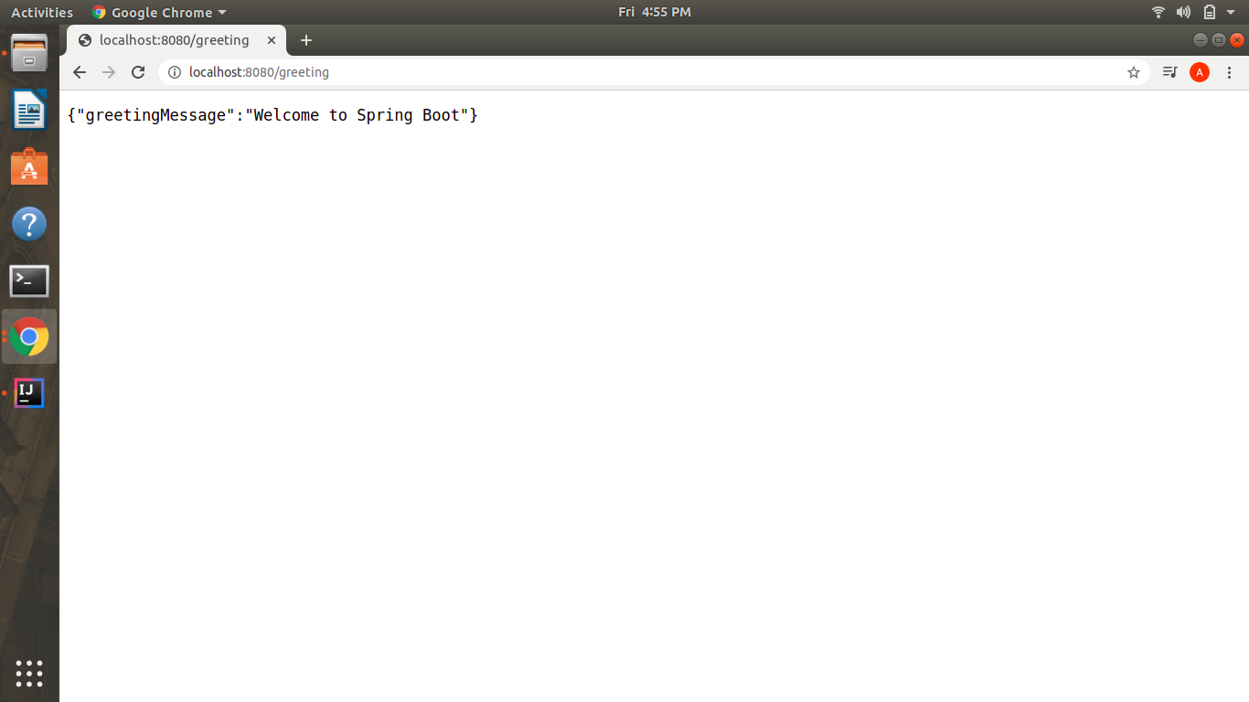

Q2)Create an Employee Bean(id, name, age) and service to perform different operations related to the employee.

Answer-Employee.java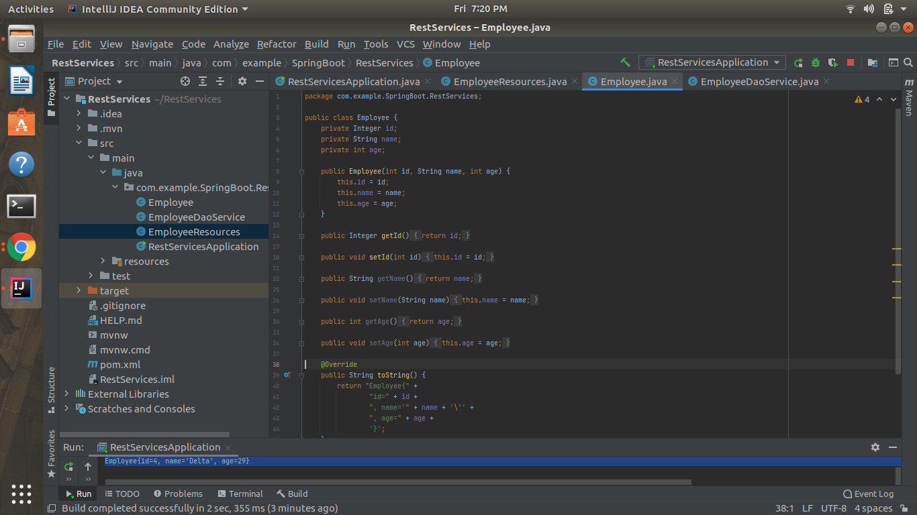

EmployeeDaoService.java

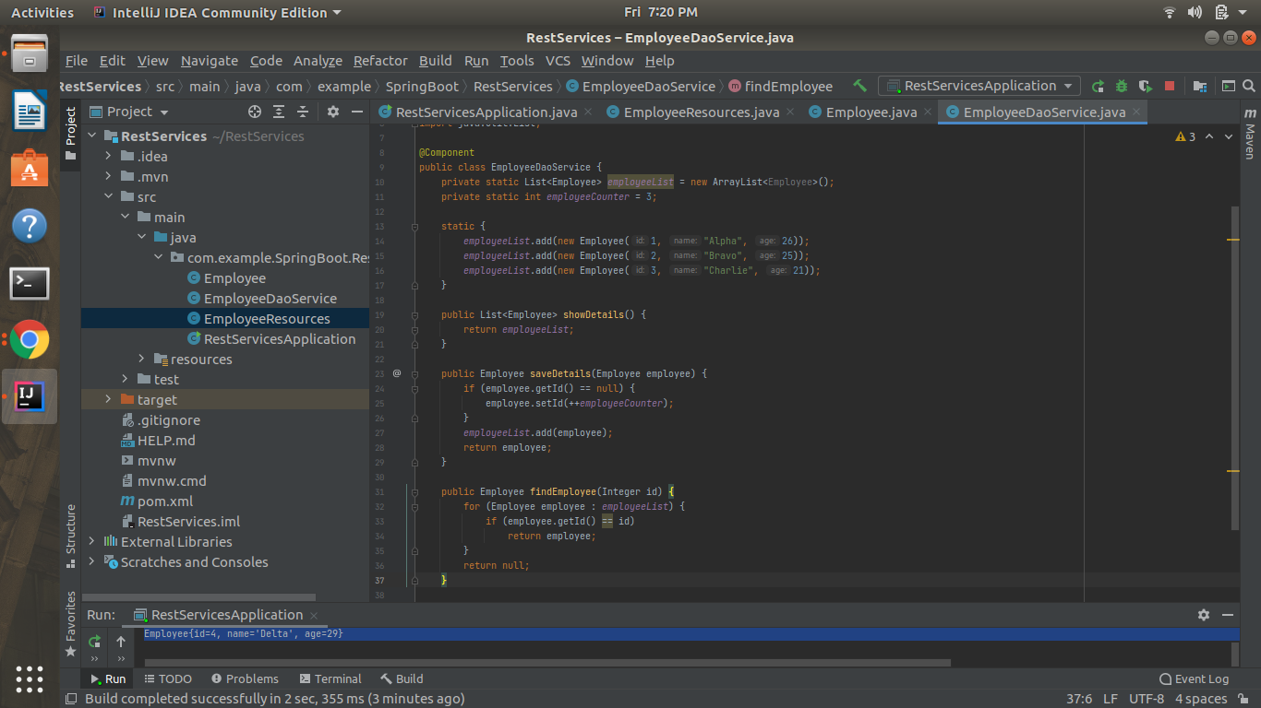

Main class(Output in console)

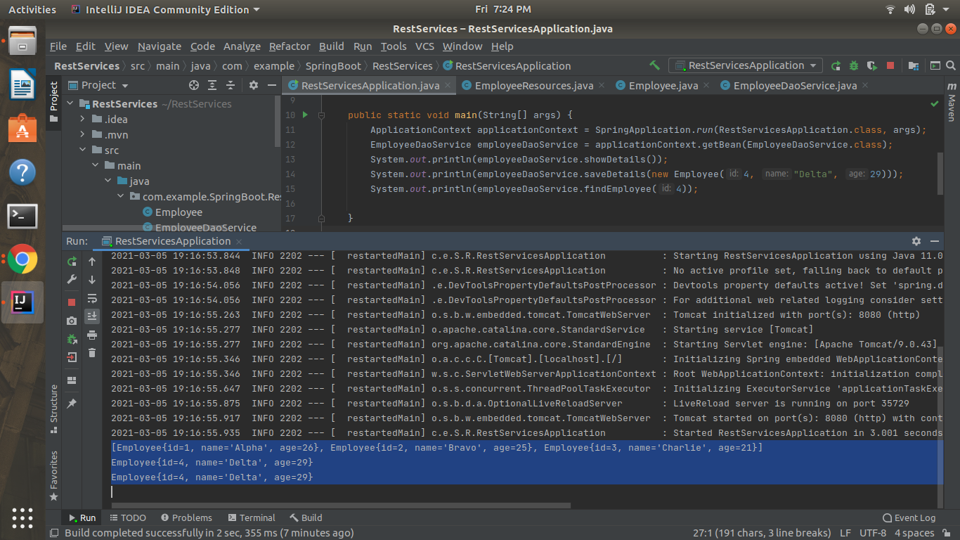

Q3)Implement a GET http request for Employee to get a list of employees.

EmployeeResources.java

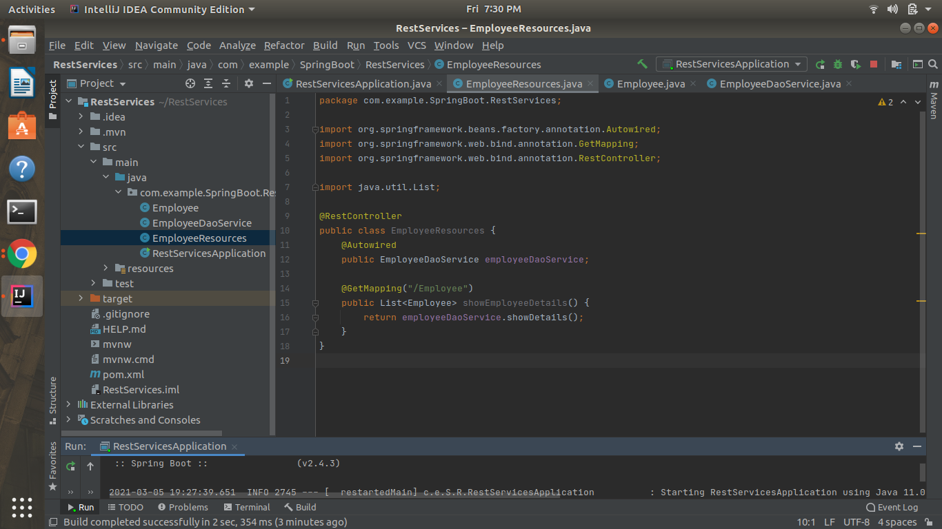

Output(localhost:8080/employee)

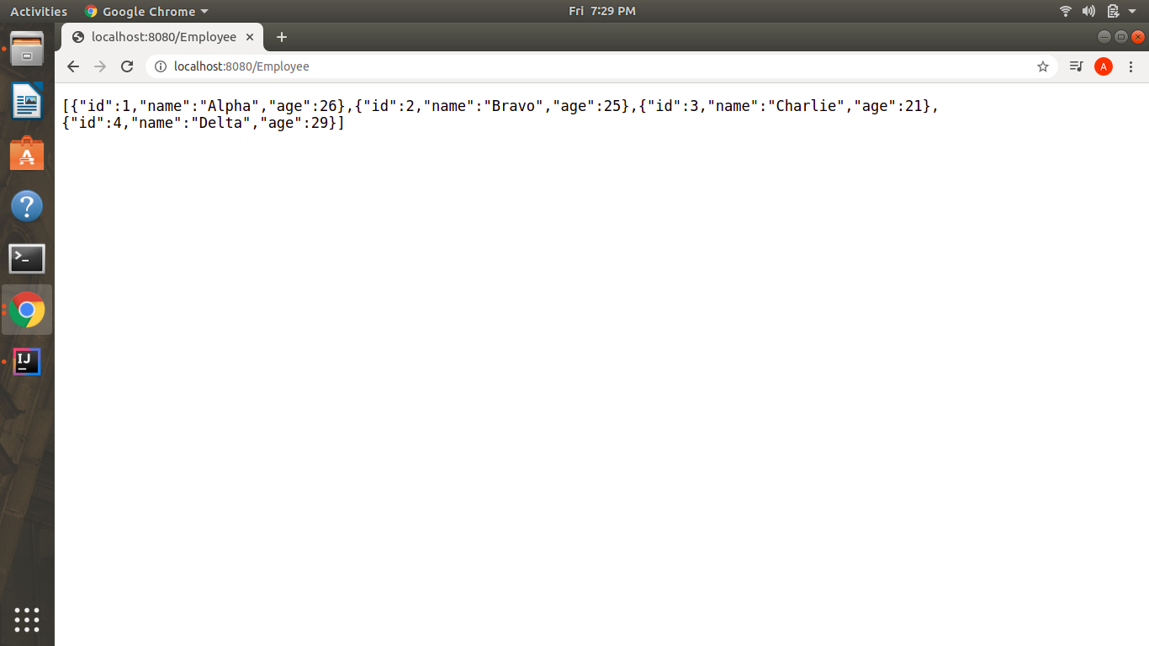

Q4)Implement GET http request using path variable top get one employee

EmployeeResources.java

**@GetMapping(“/employee/{id}”)**

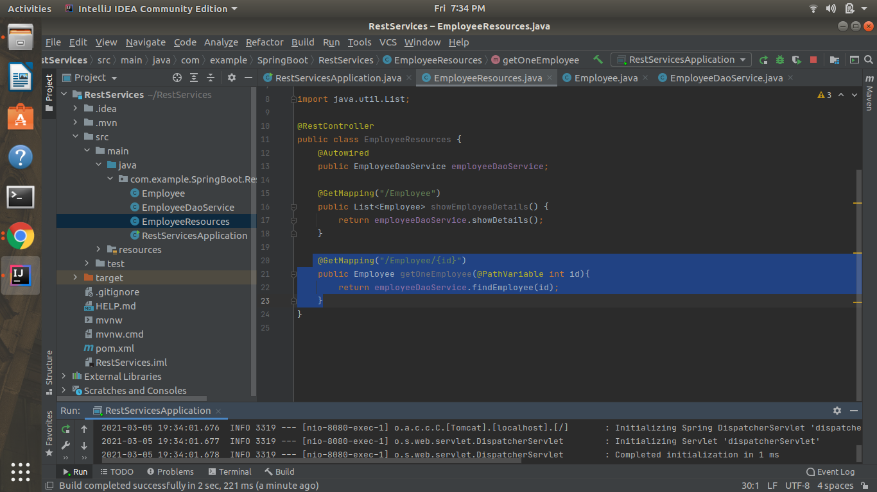

Output(localhost:8080/employee/2)

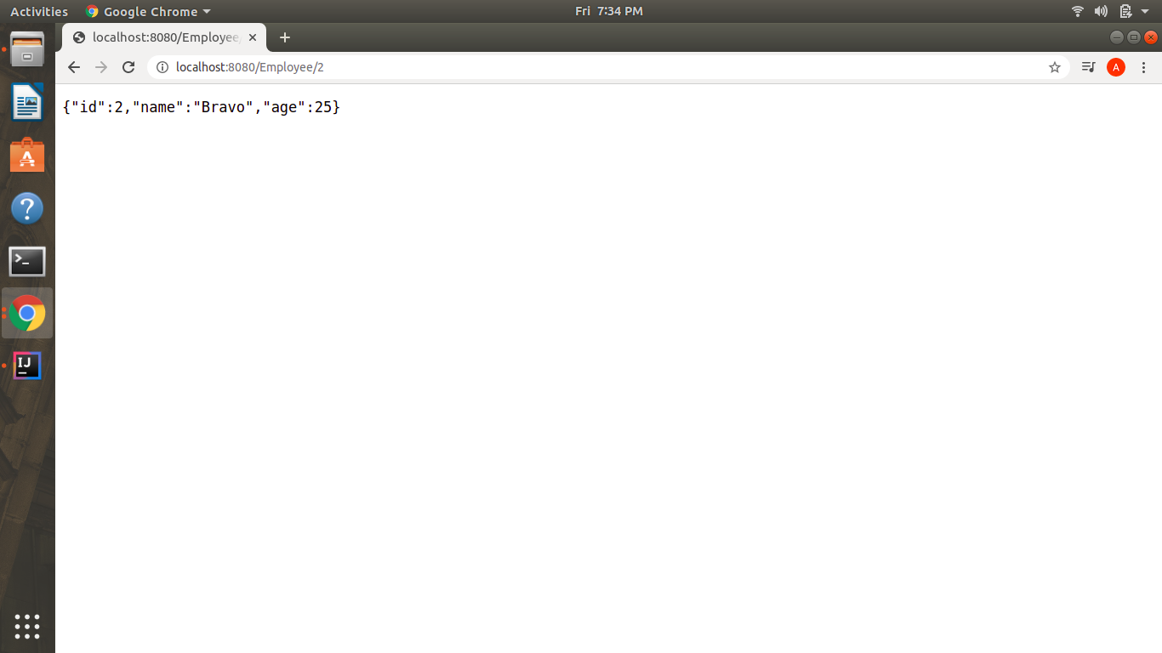

Q5)Implement POST http request for Employee to create a new employee.

**@PostMapping(“/employee”)**

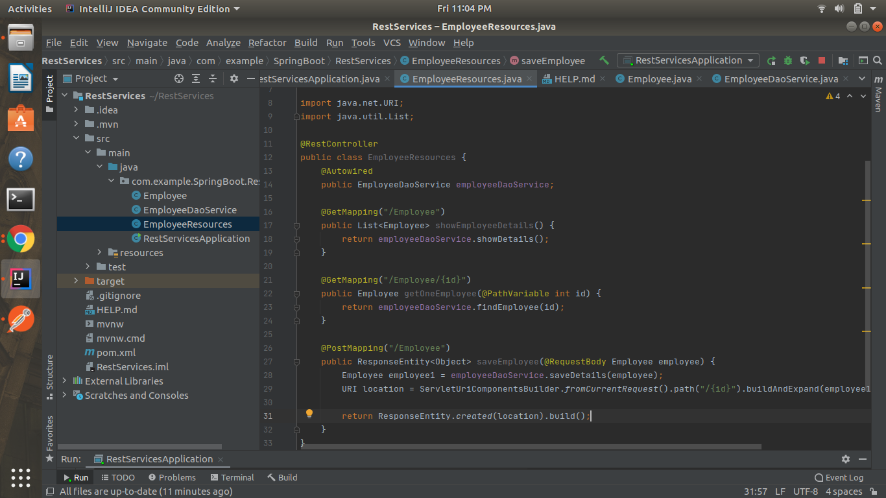

POST_localhost:8080/employee

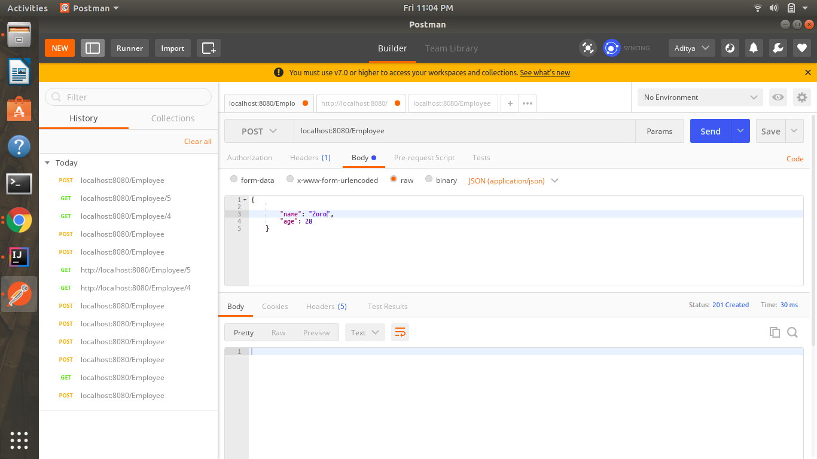

Q6)Implement Exception Handling for resource not found

**@GetMapping(“/employee/{id}”)**

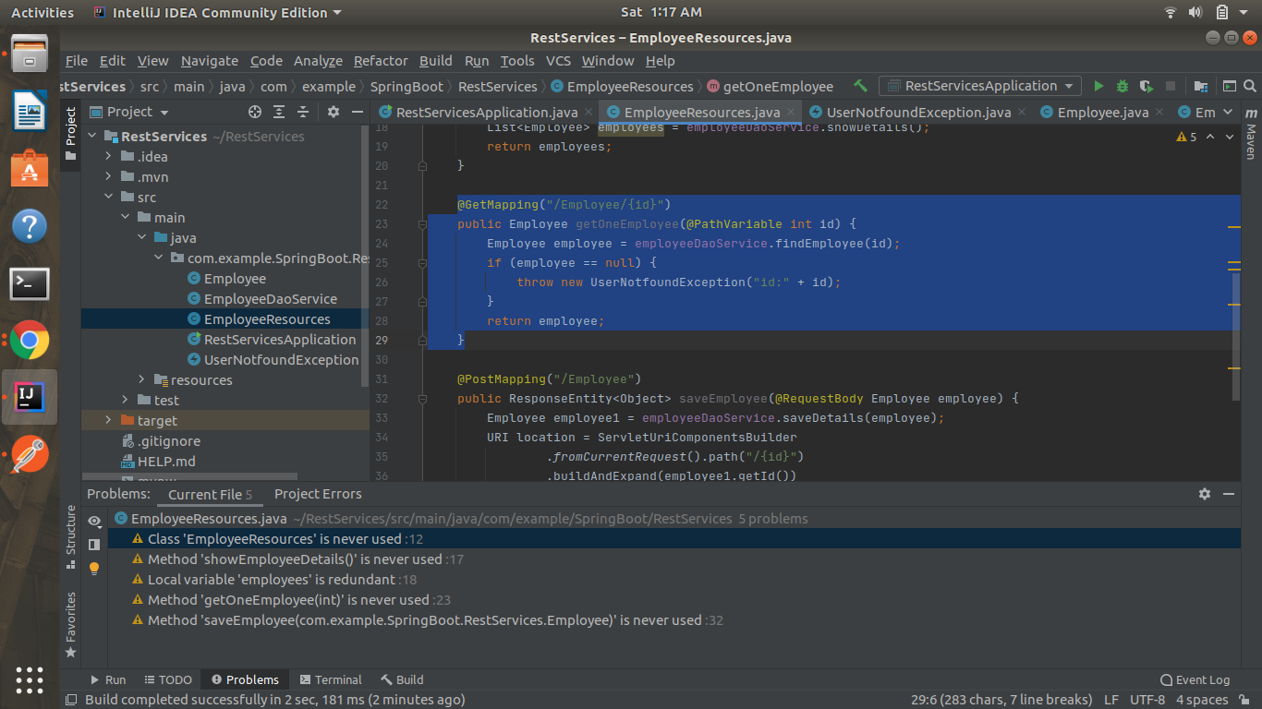

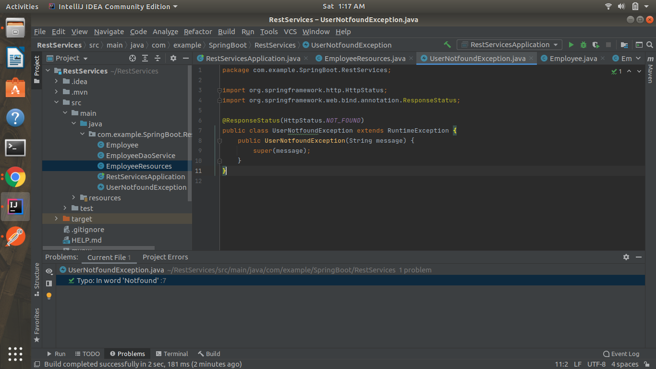

output

GET-localhost:8080/empoyee/7

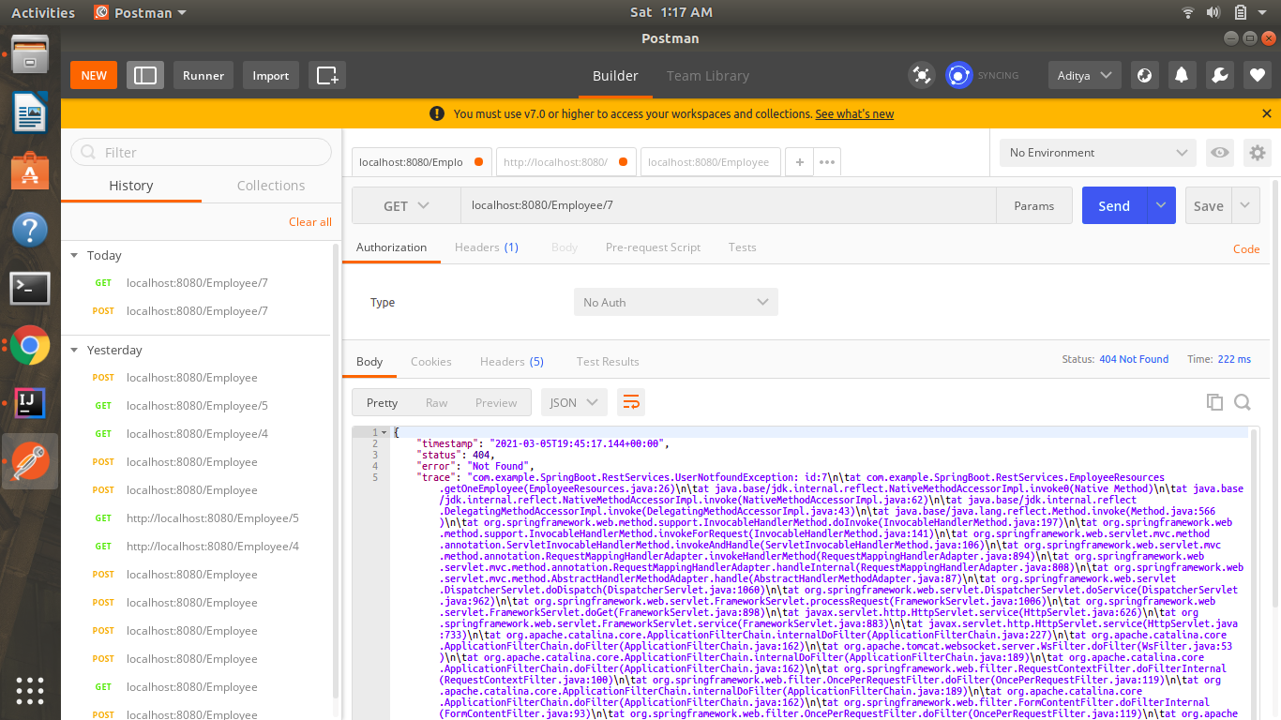

Q7)Implement DELETE http request for Employee to delete employee

EmployeeResources.java

**@DeleteMapping(“/employee/{id}”)**

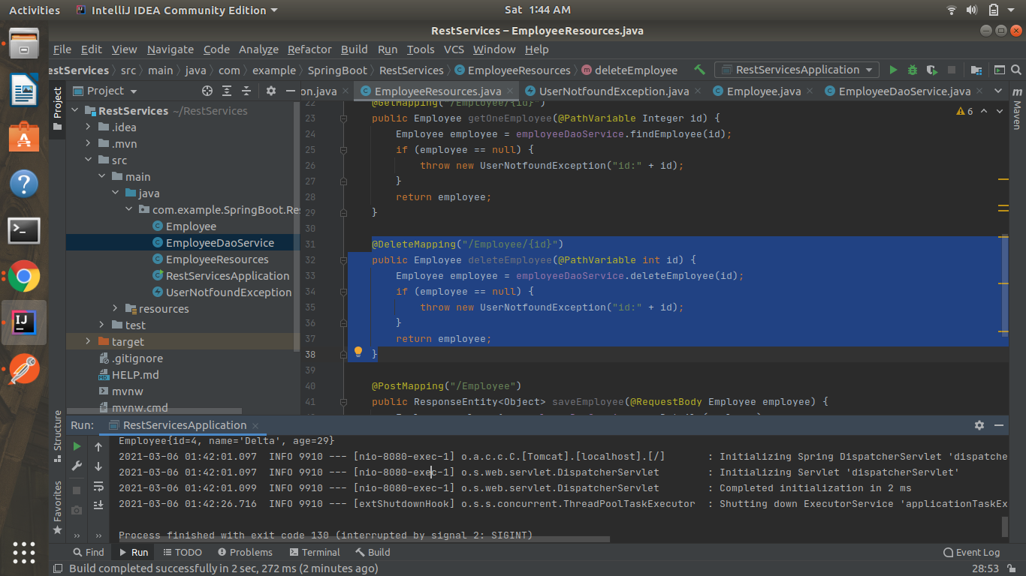

EmployeeDaoService.java

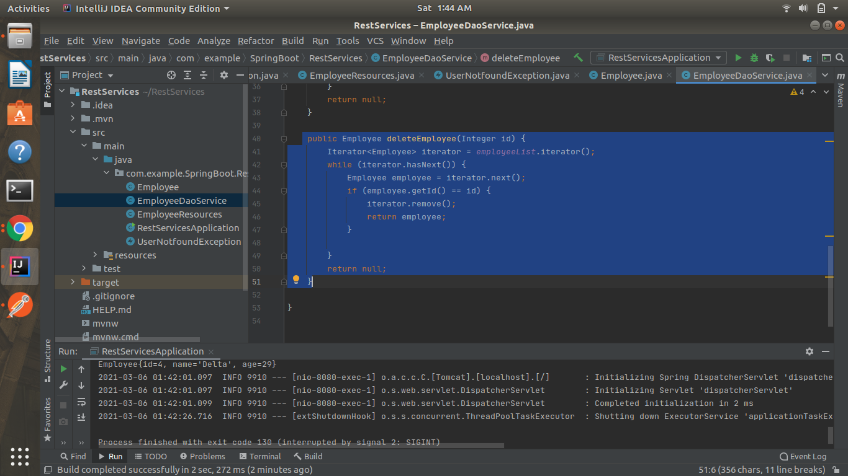

Output of Delete Request

DELETE-localhost:8080/employee/1

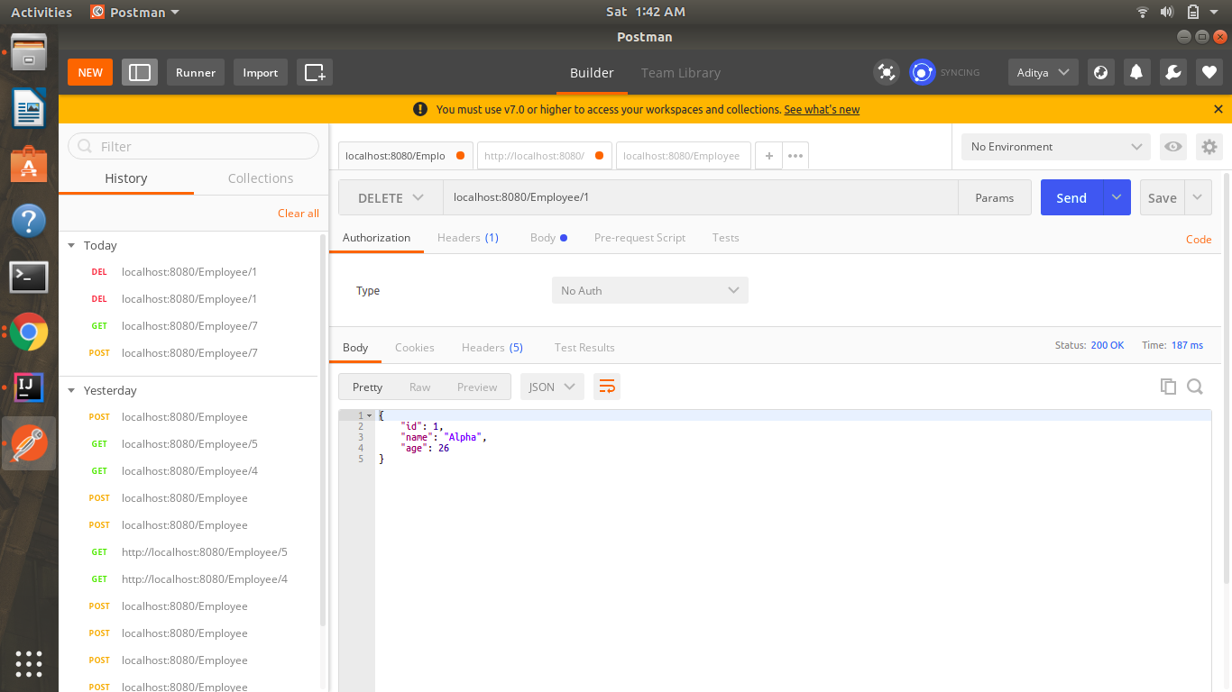

Getting Users’ Details after deleting user with id=1

GET-localhost:8080/employee/1

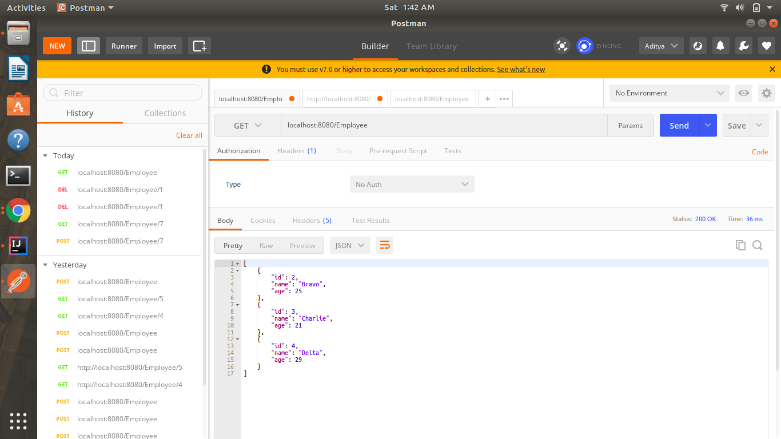

Q8)Implement PUT http request for Employee to update employee.

**@PutMapping(“/employee/{id}”)**

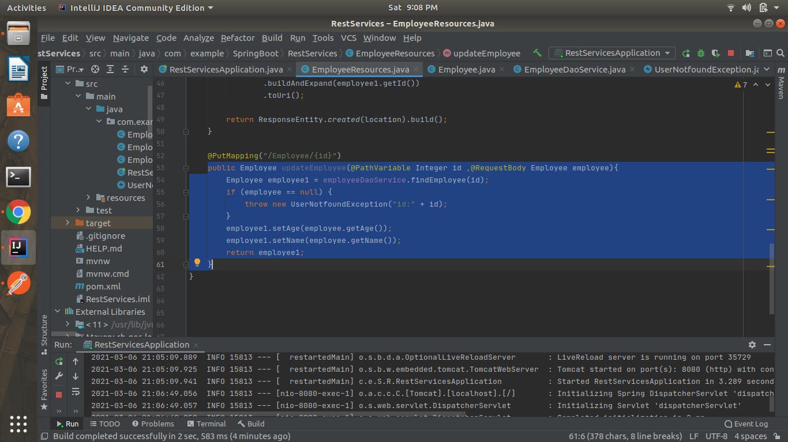

Sending a put request to update a user with id=1

PUT-localhost:8080/employee/1

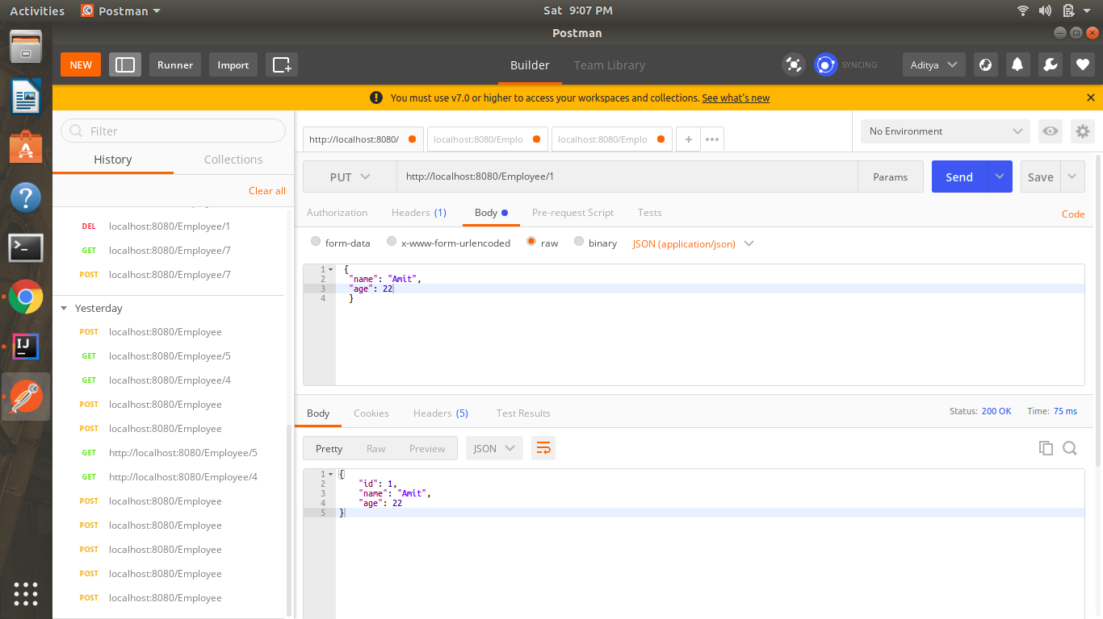

Checking the updated value

GET-localhost:8080/employee

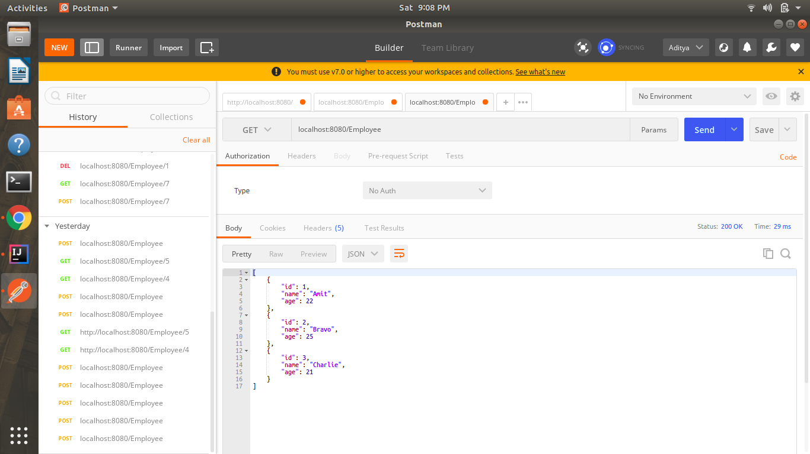

Q9)Apply validation while creating a new employee using POST http Request.

**@PostMapping(“/employee”)**

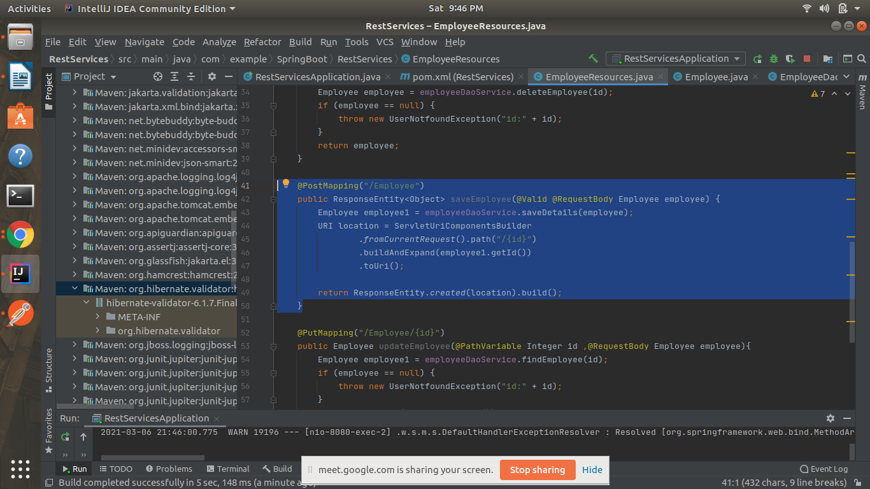

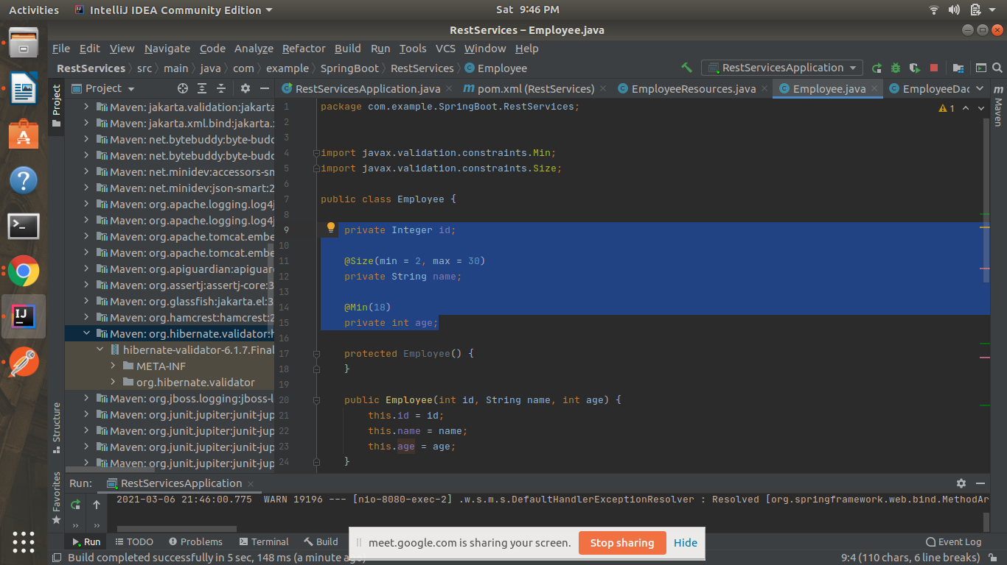

POST-localhost:8080/employee

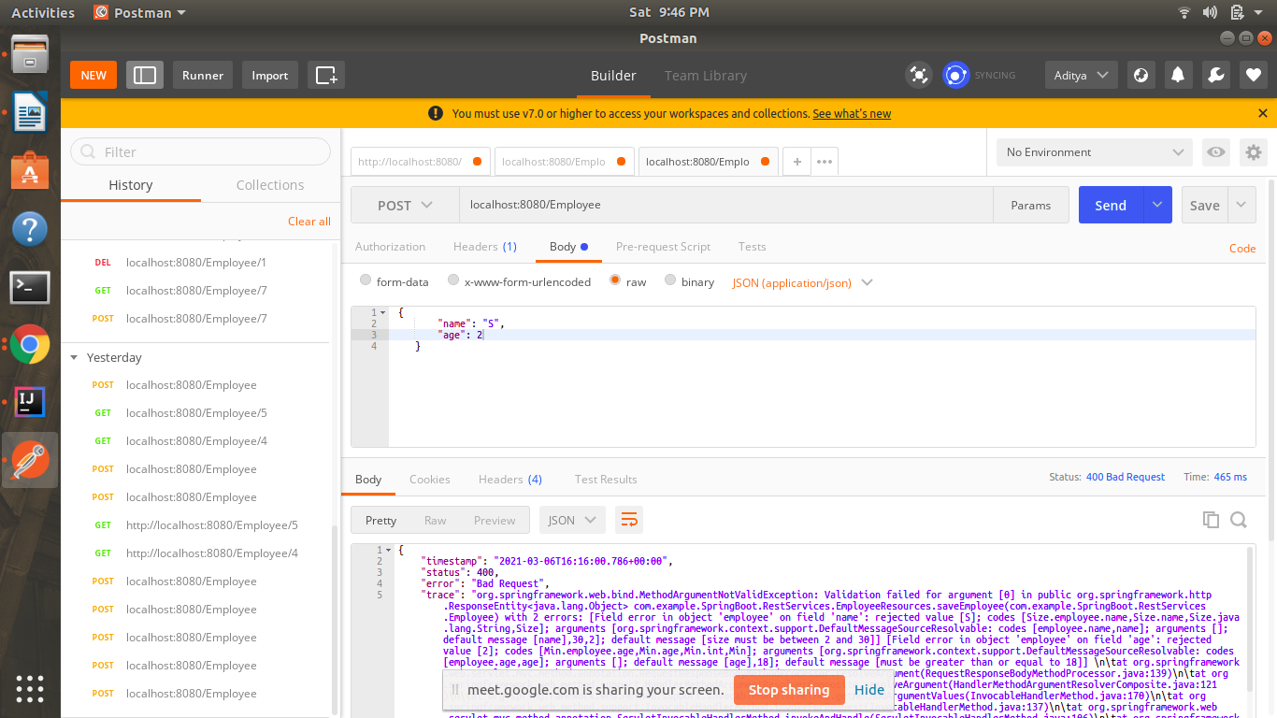

Q10)Configure actuator in your project to check the health of application and get the information about various beans configured in your application

<dependency>

<groupId>org.springframework.boot</groupId>

<artifactId>spring-boot-starter-actuator</artifactId>

</dependency>

http://localhost:8080/actuator/beans

